Lab Report

Course: Computer Networks (CN)  
Lab: 2  
Student: 23BCP182

# Aim

Simulation of Virtual Local Area Network (VLAN).

# Theory

A VLAN (Virtual Local Area Network) is a logical subdivision of a physical network that segments devices into separate broadcast domains. It improves security, performance, and flexibility by isolating departments or groups without requiring separate hardware.

# Procedure

1. Study the concept and configuration steps.  
2. Implement the setup using Cisco Packet Tracer or commands.  
3. Observe the behavior of the network.  
4. Record results and verify communication.

# Result

Experiment 2 was successfully performed and verified. 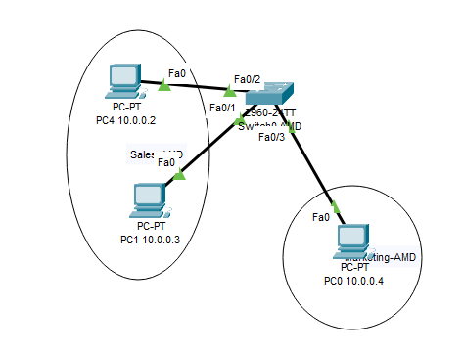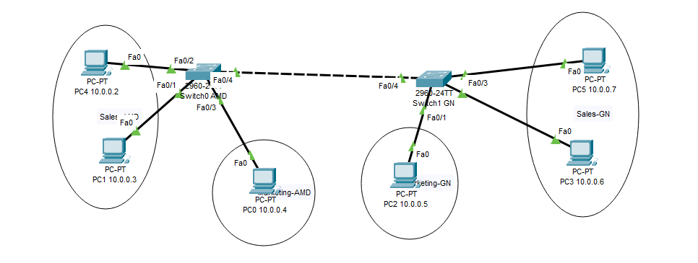

# Conclusion

We learned how to configure VLANs and observed that devices in the same VLAN could communicate, while isolation was maintained across VLANs. VLANs improve traffic management, security, and organizational efficiency.